Strategic Supply Chain Planning

Draft Tour Script

Key Messages

The following are the key messages from this tour:
- Supply chain strategy should be regularly reviewed in the light of changes in market, business strategy and technology
- A review of supply chain strategy should consider infrastructure/facilities, processes, systems and organisation
- At the core of designing an optimum supply chain is designing the right physical network, supported by appropriate processes. Computer modelling of network options is a valuable tool in such design work.

Introduction

T&K’s business has changed radically in the last year or two and even more change is expected in the next few years. For example :

- T&K is no longer just a UK retailer, with stores now in France and Germany and more planned across Europe over the next five years.
- The product mix has changed drastically – T&K no longer sells just clothes to middle-aged people; today there is a variety of products & services targeted at multiple segments.
- The store is no longer the only channel – T&K is introducing different formats, each with its own unique proposition. These include different store formats, a variety of catalogues and more recently electronic channels via the Internet and eventually with interactive TV.
- The service proposition has also changed fundamentally – today customers can order products and services specifically tailored to their needs, delivered to a location of their choice be it a store, their home, office or any other pick up point. 24 hour trading has become the norm for the electronic channels and store opening hours have also increased with the liberalisation of trading laws. A major development is the emergence of a pan-European customer base buying from multiple countries. At the same time consumers are increasingly demanding about product range and customer service.

All of these factors have created enormous challenges in the “supply chain” – the physical network, organisation, and information flows which get the right products to the customer or point of sale. Something had to be done to reconfigure the supply chain to support these new business requirements.

The current physical distribution infrastructure was unable to cope with the demands of the business. T&K had to address a number of issues from a strategic point of view :

- How should we segment the logistics operation – by geography, customer, product, customer service proposition, etc. ?
- What supply chain capacity was necessary to run the business ?
- Of this capacity, how much should be managed internally and how much should be managed by third parties ?
- What physical infrastructure was necessary in terms of distribution centres, etc. ?
- Where should this physical infrastructure be located given that the business is becoming pan-European ?
- Should we pick from DCs for the mail order / internet business or should we pick from store ?
- If we pick from DCs for mail order / internet customers, then should we have a dedicated picking centre or pick from our existing DCs that support stores ?
- How should this infrastructure be configured given that T&K now delivers large loads to stores and smaller loads to specific customers ?
- Can greater utilisation be made of existing infrastructure to get more throughput ?
- What further automation is appropriate ?

As a result of all of this, T&K developed a new supply chain strategy. We recognised that this is something which they would need to repeat from time to time and so what they have done is to introduce a more formal strategic supply chain planning process as part of their annual strategic review. It is expected that in most years, they will be able to make minor changes to their strategy but every now and again there will be a set of circumstances that force a major change. The main reason for reviewing this annually is that implementing changes may involve initiatives which require long timescales to implement. These may include new supply chain facilities or contracts (e.g. in warehousing, transport), or significant new processes/systems (e.g. computer systems).
T&K have introduced a new 5 tier strategic supply chain planning process :

- Every year, a number of indicators such as segment split, service levels, cost inflation, etc. are examined to assess whether or not the current supply chain strategy is meeting the needs of the business. External assessments are also carried out on technology, the competition and market trends.
- If it is felt that the current strategy is no longer providing the best cost / service balance in its existing form, then a wider ranging review of business requirements is conducted and various scenarios are modelled to understand requirements in more specific terms.
- If the business review indicates that more capacity, lower costs or different service is required, then the supply chain network is modelled to establish where best to have how much capacity.
- If the network model indicates the need for new distribution centres, then various configuration options are modelled to help develop a business case for the right design.
- If the requirements indicate that more needs to be obtained from existing capacity, then a more detailed machine model is developed to simulate the effects of actual automation and the options in how to configure this.

Step 1 : Triggers to review Supply Chain Strategy

Every year, T&K looks at the following indicators to establish whether or not the current supply chain strategy is delivering the required support to the business :
- Performance indicators which are worse than industry best practice: for example service levels, distribution costs per unit, stock levels, etc.
- Over- or under-capacity in current facilities
- Substantial changes in the market place, for example rising volumes, longer opening hours, different store formats
- Technology changes, such as EPOS data availability, e-commerce

Step 2 : Current and Future Business Requirements

The second step is to assess the challenge for the T&K supply chain, both currently and into the future. To do this we must look at what the T&K business will require from the supply chain. Any supply chain strategy should consider requirements for 5-10 years ahead, especially if substantial investment is required.

At the core of the challenge for the supply chain are the future demand and market requirements: the basic data for T&K to look at this is:

- Projected sales for the organisation over the next 5 years, by
- Region/area of demand
- Demand channels (stores, mail order ..)
- Product category (apparel, foods …)
- Product churn & diversity
- Market Positioning
- Financial/capital investment constraints
- Current supply chain facilities
- Characteristics of future business:
- Supplier locations
- Customer service levels /response times required or planned
- Market requirements
- Legislative restrictions (e.g. environmental)

To aid in the process of setting up the possible future scenarios we use an analysis tool set up with
data for current and projected sales, together with possible distribution points.

<<show ‘Sales Analysis Model’ here >>

- This screen shows the projected sales for T&K over the next 5 years by market, in £ p.a. For supply chain purposes, we can convert to cases.
- As you can see, there is planned to be a substantial expansion onto the continent, with non-UK sales making up over 30% of sales in 3 years time.
- Overall volumes are planned to be rising sharply: this shows that overall a rise of xx% is projected.
- If we analyse by demand channel, we see that the fastest growing element are the internet sales, which will grow to 15% of sales in 5 years time. Mail order represents a further 20%, so together 35% of volume will not be sold via stores. These will obviously mean a new challenge for the supply chain.
- Currently the demand is handled via these final distribution points. (Note: not all supply chain facilities are shown, only main ones). The current throughputs are as follows. Now, with projected volumes for 2004, using current facilities, the throughputs would be as follows. It is clear that current facilities would not cope.
- If we look at the projected demand, super-imposed with the current facilities, we can see that
- It is likely that further distribution facilities will probably be required to serve the markets in France, Belgium and Italy.
- Current facilities to handle internet/mail-order sales are insufficient for projected sales.
- If we are to move to daily replenishment of all stores, we will require a number of regional DCs in Italy and Germany.

Step 3 : Supply Chain Network Option Analysis

We have seen that projected changes in the market, and the plans that T&K have for using alternative sales channels, will lead to over-capacity for the current Distribution Centres, and will provide new challenges for the Supply Chain. It is clear that there is a requirement to set up new facilities, and to review the positions, sizes and functions of existing facilities. Overall, we need to define what the best network is for T&K, and how it will operate to support the business requirements.

To help in this task we can set up a detailed computer model of the alternative network options for T&K, simulating the effects of each option on costs and service. This uses the ‘demand scenarios’ which we developed in the “sales analysis’ model.

A variety of different computer modelling techniques can be used. Here we have used a time-based simulation package (discrete event simulation).
<<show network model here>>

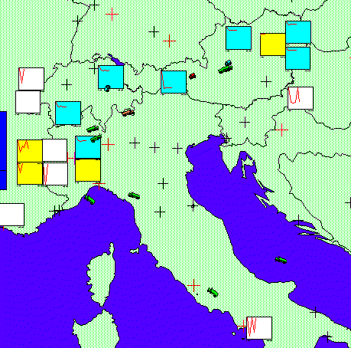

As you can see, this model simulates the entire supply chain from suppliers to stores. It can produce reports on how that network has performed.

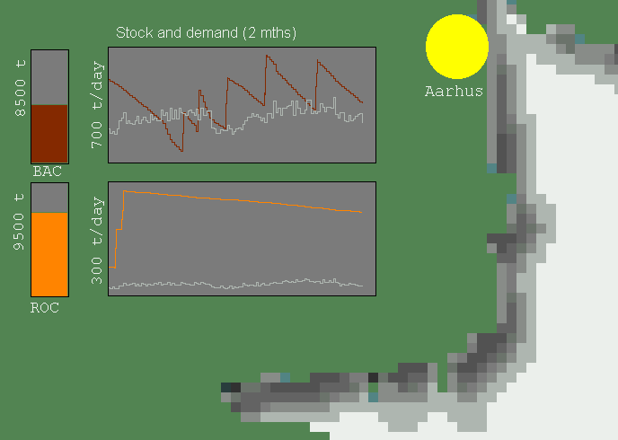

Behind this model is detailed data on the cost structures of warehousing and transport, demand information, and rules on replenishment which mimic the real life processes.

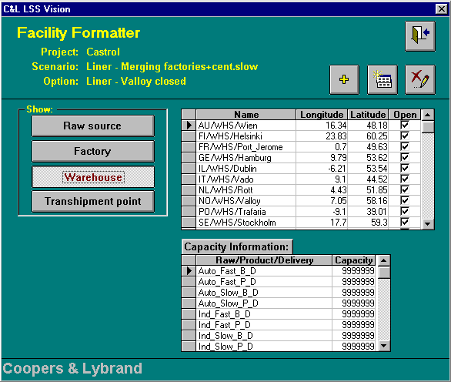

So, let us look at the ‘2004’ demand pattern for T&K and compare the performance of two alternative networks.

The first option uses two main hubs, one in Swindon and one in Strasbourg, along with 12 RDCs, 5 in the UK, 7 on the continent. Internet and mail order deliveries are handled via these hubs, as well as all product destined for stores. [need to make this consistent with our network]

The second option is made up of more specialised facilities. A centre for handling internet/mail-order despatches is located in the north of England, close to a main grouping of suppliers and in an area of low rents and wages. All apparel for Europe passes through a hub in the UK, whilst other products use a network of 3 DCs, in Swindon, Paris and Milan. A network of 10 RDCs is also in place for these products.

As we can see, the results show marked differences.

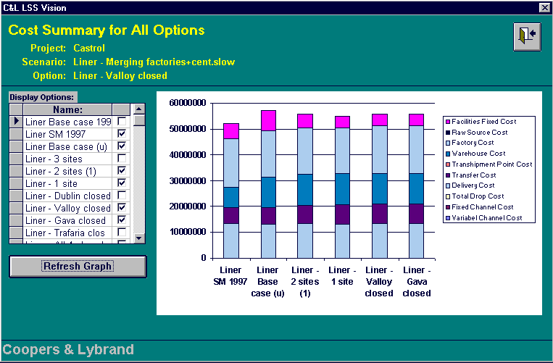

Using this model, we can arrive at the optimum network for T&K. This is as follows:
- two primary DC’s, located in Swindon, UK, and Strasbourg, France.
- Additional regional DC’s would be in a Belgium, Italy, and Germany. These regional DC’s would supply 95% of all the store needs.
- There are still some items that require direct store deliveries.
- On average, they planned for product to take less than 24 hours to pass through a given regional DC.

Step 4 – Distribution Centre Configuration

The analysis from the previous steps indicates that T&K is going to need at least one new Distribution Centre for servicing stores and another for the growing home shopping business. The capital expenditure request for £60m per DC has been taxing the board with the main concerns being :

- Do we really need 2 new DCs ?
- What if our home shopping business does not take off as forecast ?

The Supply Chain function were set with the challenge of establishing whether or not one dual purpose super DC would meet the requirements. The attraction from their point of view was that it would be a lower investment and also optimise the sale of stock through both store and home shopping channels. However, it was not easy to decide how much space to allocate to each, how to configure the DC in detail e.g. how much space to use for cross-docking versus flow racking, etc.

A warehouse simulation model was developed to test a variety of scenarios.

<<show warehouse model here>>

Step 4 – Distribution Centre Configuration

T&K’s analysis showed that adding another DC would still leave a capacity shortfall. More throughput was required from current DCs. A small parts singles picking system had already been installed. The Distribution function had various ideas on different types of automation that could be installed to increase throughput. The suppliers of these types of systems were quoting various throughput rates that sounded a little too optimistic. The T&K board wanted a degree of comfort on whether or not the favoured options would deliver the desired result since the investment ranged from £10m – £18m.

A detailed machine model was developed to simulate this and verify the suppliers estimates.

<<show machine model here>>

As it turned out, the suppliers suggested configurations would not have delivered the required throughput. However, with a few adjustments, T&K found a way of achieving more than was required.

Conclusion

We have seen that T&K cannot stand still in its Supply Chain: changes in its business and customer demands that change is essential. The cost of poor decisions can be huge in terms of high costs and poor service. Using sophisticated modelling techniques, we can develop solutions which provide

- Improved return on investment (ROI)
- Reduced business risk (investment & viability)
- More informed understanding on the cost of flexibility
- Improved service levels

Today, T&K has to use specialist systems and tools to model supply chain requirements. Tomorrow, a new breed of Advanced Planning & Optimisation systems are expected to be available to do this What If scenario modelling. T&K will review these products, including SAP’s SCOPE module and use the most appropriate technology going forward.

